**Fixing ‘/proc/sys/net/bridge/bridge-nf-call-iptables does not exist’ Error When Executing the ‘kubeadm init’ Command**

**Issue Encountered – [ERROR FileContent–proc-sys-net-bridge-bridge-nf-call-iptables]: /proc/sys/net/bridge/bridge-nf-call-iptables does not exist.**

**Understanding the Error Message**

The error message indicates that the system is unable to find the file located at /proc/sys/net/bridge/bridge-nf-call-iptables. This file is related to the configuration of network bridge settings, particularly regarding the handling of iptables rules.

**Possible Causes**

* **Missing Kernel Module**: The most common cause of this error is the absence of the necessary kernel module or support for bridge firewalling.
* **Misconfiguration**: It’s possible that the configuration for network bridge settings is incorrect or missing, leading to the error.

**Troubleshooting Steps**

1. Configure the Kernel Module ‘br_netfilter’ in the containerd configuration file.

tee /etc/modules-load.d/containerd.conf <<EOF

br_netfilter

EOF

2. Load the br_netfilter modules into the running Linux kernel.

modprobe br_netfilter

3. Update Iptables Settings.

**Note:** To ensure packets are properly processed by IP tables during filtering and port forwarding, set the **net.bridge.bridge-nf-call-iptables to ‘1’** in your sysctl configuration file. Otherwise, you may encounter the following error: **[ERROR FileContent–proc-sys-net-ipv4-ip_forward]: /proc/sys/net/ipv4/ip_forward contents are not set to 1.** To avoid this, execute the following command.

tee /etc/sysctl.d/kubernetes.conf<<EOF

net.bridge.bridge-nf-call-ip6tables = 1

net.bridge.bridge-nf-call-iptables = 1

net.ipv4.ip_forward = 1

EOF

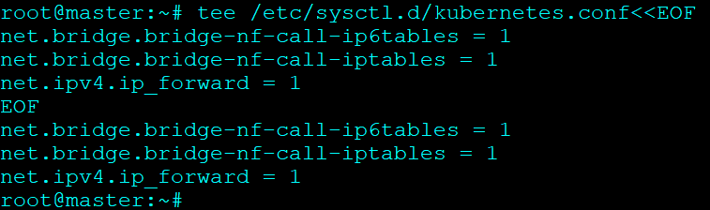

4. Applying Kernel Settings Without Reboot

sysctl --system

5. Reset Kubernetes Configuration.

Before reconfiguring, it’s crucial to reset the existing Kubernetes configuration to ensure a clean slate.

kubeadm reset

This command will revert any changes made to the cluster configuration, preparing it for a fresh initialization.

**Note:** Check out our guide to quickly [**create a three-node Kubernetes cluster on Ubuntu.**](https://k21academy.com/docker-kubernetes/three-node-kubernetes-cluster/)

6. Reinitialize Kubernetes Cluster.

Once you’ve verified and potentially adjusted the configuration, proceed with reinitializing the Kubernetes cluster.

kubeadm init

This command will initialize the cluster using the updated configuration.